Pollution – It’s Killing India
By: Enoch Zenger

India. It is home to nearly 1/5 of the world’s population, with an estimated 1.2 billion residents 1. Unfortunately, it is also home to massive environmental degradation. One of the worst offenders is pollution, mainly air and water, caused by poorly managed waste disposal and overwhelming population numbers.

Waste Disposal and Overpopulation

Waste and garbage lines the streets of major cities in India. The amount of solid waste generated per year in India weighs over 100 million tons. The situation has become so horrible that even citizens simply drop their own trash by the wayside or into rivers as they walk down the street, seeing no need to properly dispose of it in trash receptacles. This is a remarkably disturbing truth. And when the overall population of India is considered, the efforts to clean up may go unnoticed considering the large number of those who litter 2. Sadly, little effort is being made to educate those who are contributing to the issue. And what few regulations have been set forth by India’s Government, Supreme Court, and other environmental agencies go largely unenforced, or are simply disregarded 3.

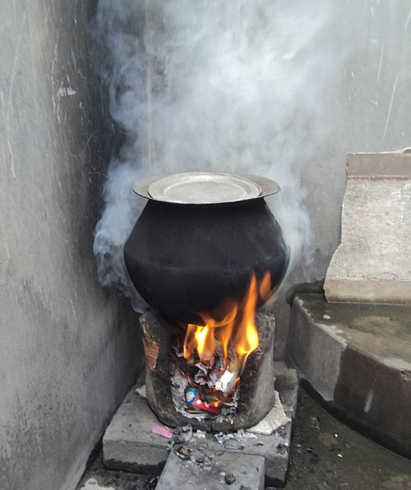
Overpopulation has also been cited a possible contributor to the pollution dilemma in India. As the second most populous country in the world, India struggles to provide sustainable, clean drinking water to all its citizens. The already large number of inhabitants strains the environmental system making it more difficult, especially as the population increases, to keep this drinking water from becoming contaminated as proper waste disposal techniques fail or are ignored 4.

Air pollution is also directly affected by the high populace of India. With the increased number of people comes an increase in fuel wood and biomass burning, fuel consumption, gas emissions from vehicles, and other greenhouse gases - for which India is the world’s third worst offender 5. Also, the majority of the country, which is known for living below the poverty line, uses trash as fuel to burn fires in order to keep warm, to dispose of the waste, and even to cook food.
Rural Stove used to burn waste. Image Source from WikipediaCommons. Author unspecified.

Anumita Roychowdhury, executive director of India’s Centre for Science and Environment, has worked in correlation with scientists from Yale and Columbia universities to produce an annual study known as the Environmental Performance Index, which offers data concerning environmental quality in regions throughout the world. She has stated that India has the worst air quality, due to pollution, in the entire world. The pollution is so bad that the harmful polluted particles found in the air are 5 times the threshold needed to cause severe disease, infection, cancer and even respiratory failure and death among its citizens. Nearly 15% of inpatient pediatric deaths in India are caused by air pollution-related incidences. And when you factor in water pollution that occurs from waste being thrown into rivers, India’s overall environmental score ranks in the bottom 5% on a worldwide scale 6.

Cities Which Are Most Affected

The issue of pollution caused by poor waste management and overpopulation is the worst in heavily urbanized, high population-density cities. The two starkest examples that we have of how bad the situation is, are the Ganges River and the city of New Delhi.

The Ganges River is one of the world’s “7 great rivers” 7. This river alone provide more than half of the country’s water needs - whether that be drinking water, bathing water, agricultural demands or other uses. That’s one river trying to provide all the water demands to a population larger than that of the United States. Due to waste disposal into the Ganges, toxic metals and chemicals (like chromium), acids (such as arsenic), radioactive chemicals (such as plutonium), and even feces have been detected in the Ganges.

Roger Choate, an organizer striving to educate and reform the dire circumstances of the Ganges River in an effort known as CleanGanga, works with students and faculty at IIT Kharagpur - India’s premiere IT University. In a blog based on personal experience he posted about the horrendous state of the river, “Every year millions of Indians are affected by waterborne diseases like diarrhea, viral hepatitis, dysentery, typhoid, cholera and gastroenteritis. People are blinded by trachoma because they can’t bathe in clean water. This is a human disaster for India and the world. The Worldwatch Institute in Washington says that, one person in the Ganga Basin dies every 60 seconds of diarrhea and eight out of every 10 Indians suffer from amoebic dysentery each year” 7. These are heart-wrenching statistics. And as if this image isn’t distasteful enough, the American writer Alexander Stille, in an article he wrote for the New Yorker, said that illnesses derived from water pollution take the lives of over 2 million children every year 8.

The notorious World Health Organization has also offered data and information on the situation in India, and inconceivable numbers have been collected. Nearly 80% of all documented health issues, and nearly 35% of all deaths, can be traced to illnesses derived directly from the Ganges River. This is due to contaminated water and particles from the river seeping into the ground-water systems, polluting water storage and disrupting agriculture 7.

In New Delhi, India’s capital, air pollution is at its worst. It covers the whole city like a cloud of death. Deaths related to air pollution reached 620,000. Aaron Cohen, an epidemiologist, states that it is simply, “...not just breathing bad air” because air pollution contributes to other diseases like cardiovascular disease, which can lead to heart attacks, strokes, respiratory infections and even lung cancer 9.

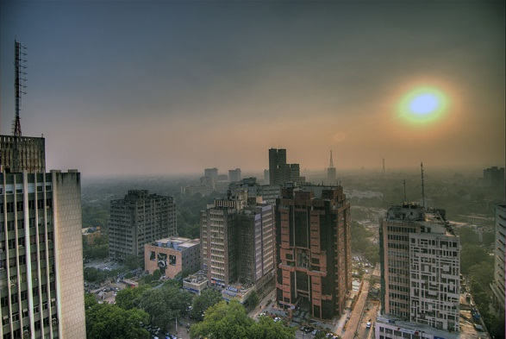
The majority of air pollution comes from gas emissions - exhaust from vehicles - which are responsible for nearly 35% of the air pollution in New Delhi, according to Dan Greenbaum, president of the Health Effects Institute. Traffic a huge issue due to the high population density, causing cars to be highly congested and run longer. This forms the terrible clouds of pollution that we see hovering over New Delhi like the Angel of Death. Other major contributors to air pollution are the factories and power plants surrounding the city. And pollution reaches its worst during the winter when civilians are burning wood, coal and trash for the purpose of keeping warm 9.
Air Pollution in New Delhi, India. Pollution is so sever, it obstructs day light, as can be seen with sun in sky and darkness over city. Image Source Wikipedia Commons. Author Wili Hybrid

Sadly, here we have two examples of how truly deadly the pollution is in India. But that’s the worst part of it - these numbers only suggest what is happening in these two areas. There is a whole country of hundreds of millions more to which the same, or similar, threats of pollution are being realized.

Why This Is Occurring

As we have mentioned to smaller extents earlier, air and water pollution are occurring because of poor waste management and unregulated burning of wood, fuels, and other materials caused by emissions from vehicles, power plants, and other facilities. However, there are a couple of big scale issues to which we must turn our attention.

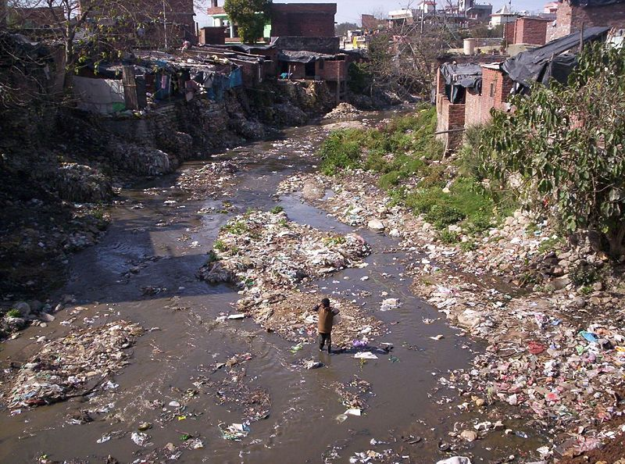
Believe it or not, Coca-Cola, everyone’s favorite late night or early morning gas station run, restaurant beverage of choice, and refrigerator space-filler, is a massive criminal-mastermind in this painful ordeal. One of Coca-Cola’s bottling plants near the village of Plachimada was rightly accused of pouring mass amounts of lead and cadmium - an extremely toxic chemical causing a number of pulmonary distresses and kidney and liver failure - into the village’s nearby river. Subsequently, a government panel from the state of Kerala, home of the Plachimada village, suggested that Coca-Cola pay a settlement fee and additional fines in excess of $47 million for damage to the water and soil in the village. Coca-Cola refused the allegations in a statement reciting that it was, “unfortunate that the committee in Kerala was appointed on the unproven assumption that damage was caused, and that it was caused by Hindustan Coca-Cola Beverages”. The panel decided, after hearing complaints from the villagers that farming, crops, and livestock were gravely affected, not to renew the license of the plant, which closed after the panel hearing deciding it would be “best to move elsewhere” 10. Coca-Cola had been poisoning the village on land and in water 11.
Rivers, like this one, are found all throughout India, filled with waste, garbage, and harmful chemicals, like the ones discharged by Coca-Cola into water sources. Image Source taken from Wikipedia Commons. Author is Meg Rahul.

Although companies like Coca-Cola are prime examples of those who are hurting India, we must still realize that the greatest problem comes from the very people who inhabit the country of India. Oliver Wakefield, a reporter who gathers statistics and information from directly within India, has declared, “India appears to be digging its own grave deeper and quicker than the rest of us, nearly 30% of India's gross agricultural output is lost every year due to soil degradation, poor land management and counter-productive irrigation” 2. Here Wakefield paints a clear, but disturbing picture of how the situation has reached its current terrible state because of lack of wise land-use choices. If better management and choices were made regarding land-use, better quality water would be available to hundreds of millions of people.

Further examples of how people are shooting themselves in the foot include the raw sewage and industrial waste that is continuously pumped into the Indian Ocean. This poses the difficult challenge of acquiring fresh water. When people continuously, and without reserve, dump polluted materials into their water, they can expect to get polluted water out of the equation. However, Coca-Cola did also contribute to the situation as stated earlier by diverting fresh water to their plant and returning toxic sludge to the environment. As they committed this gross crime, millions went without fresh water 2, 11.

It has already been made known that India has the world’s worst air quality. An inarguable and un-debatable truth is that the transport system is by far and large the worst contributor to air pollution in India. The largest cities, New Delhi and Mumbai, have millions and millions of citizens who drive old, dirty diesel engines which emit millions of tons of sulphur. This is appalling because modern technology and innovation has allowed western civilization to come up with alternatives, like train and bus systems, as well as less harmful pollutants, like natural gas and hybrid vehicles. India, however, is still far behind this 21st century reality. One of the many sad and terribly by-products of this terrible air pollution is the asthma rates (50% and rising) of young children and adolescents _{6, 9}.

Steps Being Taken To Improve India

Fortunately, there are many who are striving endlessly to make a difference and ensure a better future for this aching country. Most of the efforts are being made by normal, everyday life civilians, followed by scientists and environmentalists. Very few of the efforts are coming from India’s government.

Roger Choate, whose information has been a great help to this article, leads two significant campaigns to improve life in India. He takes so much pressure upon himself to aid relief because, in his opinion, little is being done by the government, and what little effort is being made has been ineffective. In 1985, the government did launch a so-called “Ganges Action Plan” in 29 cities throughout the country. The plan called for attempts to clean up pollution of water sources by instigating a series of water treatment facilities. The initiative failed miserably because of mistakes made by engineers, over-dependence on electrical power, mass flooding, and poor maintenance of each of these occurrences ₇.

This was not acceptable to Choate. His two campaigns were more carefully planned and passionately executed. His first campaign, CleanGanga, is focused on legal rights. It started with education and increased awareness of the community, an integral part of achieving success in any public endeavor. Roger is has been teaching workshops in the Ganga Basin informing local council people about rights of the 74th Amendment to the Indian Constitution, to which India’s people are entitled. This amendment gives legal precedence for local officials to seize control of environmental actions and seek better accommodations for the civilian population they represent.

Choate’s second campaign, Swatcha Ganga, focuses on health treatment for those affected by polluted water from the Ganges River. Roger gathers medical supplies and renders care to those in need ₇. His work is critical because of the lack of governmental attention given to civilians in need of healthcare at state and government hospitals ₇.

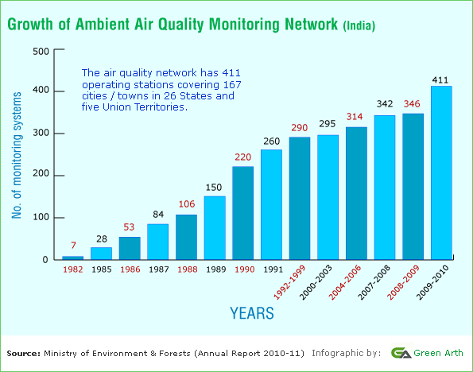
Roger Choate has pledged that he’ll never stop advocating increased legal responsibility and better healthcare to those of the Ganga Basin. However, nearly 6 years after starting his campaigns, Choate stated in a post on his own blog that, “little has changed” as far as the government’s attempts to help the public. ₇

Some agencies, however, have implemented monitoring systems to help measure pollution. The Ministry of Environment, with the help of the EPA (Environmental Protection Agency), has, as of 2010, installed 411 air monitoring systems in 167 cities in India. This is a great first step, but monitoring alone is not enough to improve air quality. Now steps must be taken to get rid of the pollutants and start implementing more effective cars, contained burning, and regulated waste control ₁₂.
Graph showing the installations of air monitoring systems implemented by the Ministry of Environment and EPA. Image Source Ministry of Environment Annual Report 2010-2011
Recently, the high court of Allahabad - the local government head for the state of Uttar Pradesh - ordered the immediate ceasing of all construction that dumped waste into the Ganges River, and mandated the immediate commencement of new waste treatment facilities _{13.} Over a period of time, these measures will help ensure that vitally needed fresh water is more accessible to the Ganga Basin’s residents.

Finally, the Foundation for Sustainable Development (FSD), an organization focused on providing sustainable resources to impoverished areas, has worked to implement water treatment machines along the Ganges River. These efforts have been extremely beneficial, according to FSD intern Elizabeth Thys, who was responsible for working with the Foundation for Ecological Security (FES) in India’s water engineering systems - which gather and filter rainwater making it drinkable for residents. These gathering systems improved both quality and accessibility of drinking water for the entire area Rajasthan - a primary city of focus for the FSD ₁₄.

So as we can see, the pollution of air and water in India is a very serious matter which is wreaking unparalleled havoc on the populations of the Ganges River and urban population centers like New Delhi. Thankfully, however, we do have those brave and fearless enough to acquire the necessary resources and help pioneer an effort to assist not only those currently in need, but those of a future generation who need a better, safer, environmentally-healthier India, free from the crippling disease of environmental degradation.

1. http://www.indiaonlinepages.com/population/india-current-population.html
2. Oliver Wakefield. “Environmental Issues In India” http://www.all-about-india.com/Environmental-issues-in-India.html India.com. Web. 2012.
3. Akash Kapur"Drowning in a Sea of Garbage". The New York Times. Web. April 22, 2010.
4. Anne Hoevel “Overpopulation could be...the problem” http://www.cnn.com/2007/TECH/science/09/25/overpopulation.overview/index.html CNN. Web. April 8, 2008.
5. Maria Van der Hoeven contributor "CO2 EMISSIONS FROM FUEL COMBUSTION HIGHLIGHTS, 2011 Edition". International Energy Agency, France. 2011.
6. Heather Timmons and Malakiva Vyawahare “India’s Air the World’s Unhealthiest... ” http://india.blogs.nytimes.com/2012/02/01/indias-air-the-worlds-unhealthiest-study-says/ NYTimes, International Herald Tribune. Web. February 24, 2013.
7. Roger Choate “River Pollution Affects Millions!” http://gangajal.org.in/blog/2009/01/14/river-pollution-affects- millions-by-roger-choate/. Gangajal Blog. Web. 2003.
8. Alexander Stille “The Ganges’ Next Life http://www.newyorker.com/magazine/bios/alexander_stille/ The New Yorker. Published. Web. January 19, 1998
9. Amy Yee “The Air That Kills In India” http://green.blogs.nytimes.com/2013/02/14/the-air-that-kills-in-india. NYTimes. Web. February 14, 2013.
10. Hari Kumar “Pollution Fine Sought Against Coca-Cola” http://www.nytimes.com/2010/03/24/world/asia/24briefs-Indiabrf.html?_r=1& NYTimes. Web. March 23, 2010
11. Larry West “Coca-Cola Charged with Groundwater Depletion and Pollution in India” http://environment.about.com/b/2006/09/08/coca-cola-charged-with-groundwater-depletion-and-pollution-in-india.htm Environmental Issues-About.com Web. September 8, 2006.
12. http://www.epa.gov/international/regions/Asia/india/past.html. Environmental Protection Agency official website. Web. Last updated April 19, 2012
13. Dan Morrison” India Stems Tide of Pollution Into Ganges River: Legal rulings block development projects in bid to enhance water quality”. http://news.nationalgeographic.com/news/2011/11/111123-india-ganges-river-pollution/. National Geographic. Web. November 23, 2011.
14. Contributors from the Huffington Post http://www.fsdinternational.org/country/india/envissues FSD (Foundation for Sustainable Development). Web.

